**Component-Based Libraries**

Component-based libraries are tools that allow developers to write CSS directly within JavaScript, providing:

1. **Scoped Styles**: Styles are tied to specific components, avoiding global scope conflicts.
2. **Dynamic Styling**: Styles can be dynamically updated based on component props, state, or themes.
3. **Improved Developer Experience**: Enhanced readability and maintainability with clean and modular code.

Two of the most popular libraries in this category are **Styled Components** and **Emotion**.

**1. Styled Components**

**What Are Styled Components?**

Styled Components is a library for React and other frameworks that uses tagged template literals to style components. It allows you to define styles directly in your JavaScript files, creating isolated and maintainable styling solutions.

**Key Features**

1. **Scoped Styling**
   * Styles are encapsulated within a component, avoiding global namespace conflicts.
2. **Dynamic Styling**
   * Supports passing props to dynamically adjust styles.
3. **CSS Syntax**
   * Utilizes traditional CSS syntax, making it easy for developers familiar with CSS.
4. **Theming Support**
   * Built-in support for themes using the ThemeProvider.
5. **Automatic Critical CSS**
   * Automatically generates optimized styles, ensuring only the required CSS is included in the final bundle.

**Getting Started with Styled Components**

**Installation**

npm install styled-components

**Basic Usage**

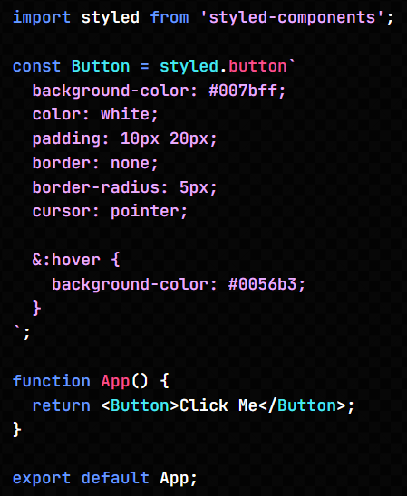

In this example:

* The Button styled component is scoped to the App component.
* Styles are encapsulated and do not affect other elements.

**Dynamic Styling with Props**

Styled Components allow dynamic styles based on props passed to the component:

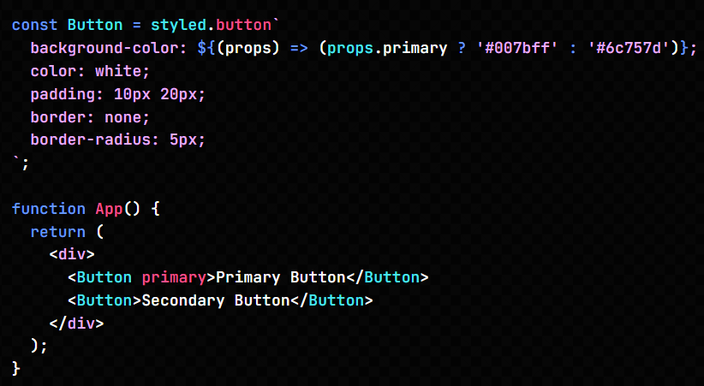

**Theming with Styled Components**

The ThemeProvider allows global theme management:

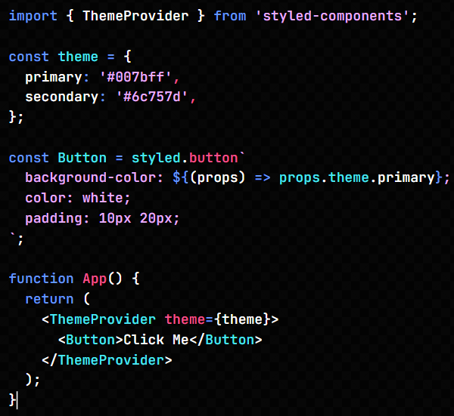

**2. Emotion**

**What is Emotion?**

Emotion is a powerful and flexible library for writing CSS styles with JavaScript. It provides both a CSS-in-JS solution and a styled-component-like API, allowing developers to choose their preferred approach.

**Key Features**

1. **Flexible Styling Approaches**
   * Supports styled components, object styles, and traditional CSS-in-JS.
2. **High Performance**
   * Optimized for runtime performance and minimal overhead.
3. **Dynamic Styling**
   * Enables dynamic styles based on props or state.
4. **Theming Support**
   * Integrates seamlessly with theming systems.
5. **Class Name Generation**
   * Automatically generates unique class names to prevent style conflicts.

**Getting Started with Emotion**

**Installation**

npm install @emotion/react @emotion/styled

**Basic Usage with Emotion's Styled API**

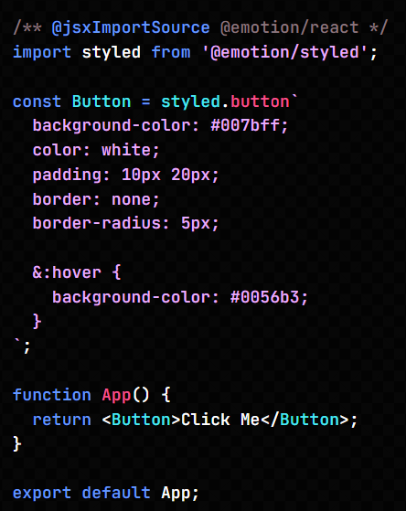

**Using Emotion's CSS API**

Emotion also provides a css function for inline CSS:

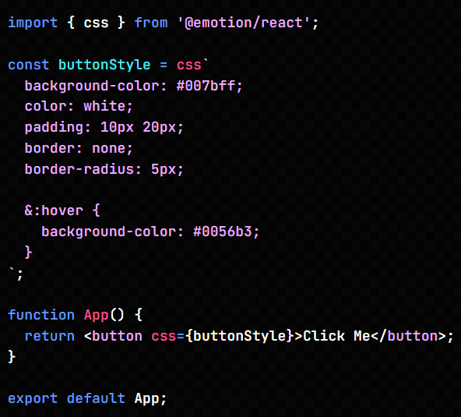

**Dynamic Styling with Props in Emotion**

Similar to Styled Components, Emotion supports dynamic styles:

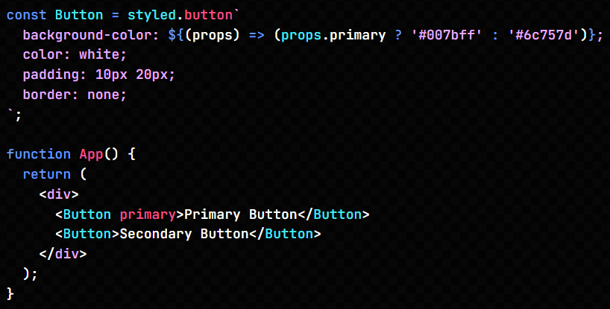

**Theming with Emotion**

Emotion uses a ThemeProvider for global theme management:

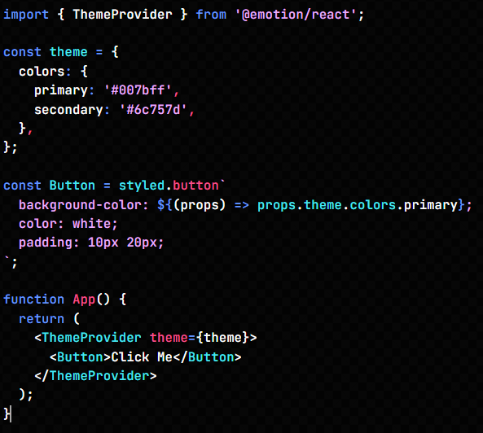

**Comparative Advantages of Styled Components and Emotion**

| **Feature** | **Styled Components** | **Emotion** |
| --- | --- | --- |
| **Styling Syntax** | CSS-in-JS (template literals) | Multiple options: template literals, CSS prop, and object styles |
| **Flexibility** | Limited to template literals | Highly flexible with various approaches |
| **Performance** | Optimized | Optimized with runtime efficiency |
| **Community and Ecosystem** | Larger community with rich resources | Smaller but growing ecosystem |
| **Theming Support** | Built-in | Built-in with advanced features |

**Further Reading**

* [Styled Components Official Documentation](https://styled-components.com/docs)
* [Emotion Official Documentation](https://emotion.sh/docs)
* [CSS-in-JS: An Overview](https://css-tricks.com/css-in-js/)
* [Component-Based Design in React](https://reactjs.org/docs/components-and-props.html)